Class I G.K. – 20th August 2019; Tuesday :
ALERT: BE WELL PREPARED & ALL THE BEST FOR THE MILESTONE OLYMPIAD [MSO-GK] on 29-08- 2019; Thursday. Good Luck!
1. Mr. Narendra Modi , won the elections in May 2019 and has become the
Prime Minister of India for the ________________ time?
i. second ii third iii. fourth iv. first
2. Which among the following does not have a tail? _______________
i. Kite ii Bird iii. Squirrel iv. Baby boy.
3. Which among the following does not ring? ___________
i. Door-bell ii Telephone iii. Ear- ring iv. Wind-chimes
4. Which among the following places is closest to Bhilai? ____________
i. Durg ii Rajnandgaon iii. Indore iv. Raipur
*****************************************************************
Class II G.K. – 20th August 2019; Tuesday :
ALERT: BE WELL PREPARED & ALL THE BEST FOR THE MILESTONE OLYMPIAD [MSO-GK] on 29-08- 2019; Thursday. Good Luck!
1. What is the colour of mud / soil
i. White ii. Brown iii. Blue iv. Green.
2. Which among the following grows in water?
i. Sunflower ii Lotus iii. Rose iv. Jasmine
3. Which among the following moves under water?
i. Boat ii Ship iii. Submarine iv. Steamer
4. Which is not worn by males?
i. trousers and shirt ii shorts and T-Shirt
iii Saree and Blouse iv. Dhoti and Kurta
*****************************************************************
Class III G.K. – 20th August 2019; Tuesday :
ALERT: BE WELL PREPARED & ALL THE BEST FOR THE MILESTONE OLYMPIAD [MSO-GK] on 29-08- 2019; Thursday. Good Luck!
1. Which among the following is not a currency note?
i. paisa ii. dollar iii. rupee iv. pound
2. Who among the following was in the court of Akbar?
i. Birbal ii. Tenaliraman iii. Narad iv. Gopal Bhand
3. If currency notes are printed then coins are made in a ___________
i. Bank ii. Mint iii. Mine iv. Treasury
4. Which among the following places is not along the sea coast:
i. Chennai ii. Bhopal iii. Puri iv. Vishakapatnam

*****************************************************************
Class IV G.K. – 20th August 2019; Tuesday :
ALERT: BE WELL PREPARED & ALL THE BEST FOR THE MILESTONE OLYMPIAD [MSO-GK] on 29-08- 2019; Thursday. Good Luck!
1. Which among the following does not manufacture Computers?
i. Hindustan Machinery Tools- HMT ii. DELL iii. Sony iv. Hewlett Packard
2. Which food and State are not correctly matched?
i. Dhokla- Maharashtra ii. Khakra- Gujarat
iii. Litti- Chokha -Bihar iv. Tamarind Rice-Kashmir
3. Which city and its leading industry is a mismatch?
i. Dhanbad- Coal Capital ii. Rourkela- Ispat ( Iron & Steel)
iii. Surat –Textiles iv. Raipur-Leather Goods
4. Which among the following Singers and and Style of Music is a mismatch?
i. Teejan Bai- Pandwaani ii. Nooran Sisters- Rajasthani folk
iii. Waddali Brothers –Sufi Music iv. Tamarind Rice-Assamese folk
*****************************************************************
Class V G.K. – 20th August 2019; Tuesday :
ALERT: BE WELL PREPARED & ALL THE BEST FOR THE MILESTONE OLYMPIAD [MSO-GK] on 29-08- 2019; Thursday. Good Luck!
1. Which among the following is NOT located in Asia?
i. Libya ii. Bhutan iii. Mayanmar iv. China
2. Which among the following is not a neighbouring country of India?
i. Bhutan ii. Nepal iii. Japan iv. Pakistan
3. Which among the following is NOT a man-made wonder of the world?
i. Mount Everest in the borders of Tibet & Nepal ii. Pyramids of Egypt
iii. Great Wall of China iv. Taj Mahal of Agra
4. Which among the following is a MISMATCH?
i. Gateway of India- Mumbai ii. Sanchi Stupa- Uttar Pradesh
iii. Sun Temple Odisha iv. Jantar Mantar- Jaipur
*****************************************************************
Class VI G.K. – 20th August 2019; Tuesday :
ALERT: BE WELL PREPARED & ALL THE BEST FOR THE MILESTONE OLYMPIAD [MSO-GK] on 29-08- 2019; Thursday. Good Luck!
1. Which among the following rivers flows eastwards?
i. Tapti [ ] ii. Teesta [ ] iii. Mahanadi [ ] iv. Brahmaputra [ ]
2. Who among the following is the current Chairman of ISRO?
i. Dr. K. Sivan [ ] ii. Shri Satish Dhawan [ ]
iii. Shri A S Kiran Kumar [ ] iv. Dr. K Radhakrishnan [ ]
3. How many number keys are there in the modern computer keyboard?
i. Twenty [ ] ii. Twelve [ ] iii. Five [ ] iv. Seventeen [ ]
4. Which among the following is an incorrect match?
i. Assam - Bihu [ ] ii. Arunachal Pradesh – Monpa [ Lion and Peacock Dance] [ ]
iii. Punjab- Bhangra & Gidda [ ] iv. Karnataka- Lahiroba [ ]
*****************************************************************
Class VII G.K. – 20th August 2019; Tuesday :
ALERT: BE WELL PREPARED & ALL THE BEST FOR THE MILESTONE OLYMPIAD [MSO-GK] on 29-08- 2019; Thursday. Good Luck!

1. Expand the abbreviation IPCC: _________________________________________
2. Who created the character Sherlock Holmes?
i.Agatha Christie [ ] ii. Sir Arthur Connon Doyle [ ]
iii. William Shakespeare [ ] iv. Emilie Bronte [ ]

3. Expand the abbreviation NCC: _________________________________________
4. Who is the author of Abhigyana Shakuntalam?
i. Kabirdas [ ] ii. Panini [ ]
iii. Kalidasa [ ] iv. Tulsidas [ ]
*****************************************************************
Class VIII G.K. – 20th August 2019; Tuesday :
ALERT: BE WELL PREPARED & ALL THE BEST FOR THE MILESTONE OLYMPIAD [MSO-GK] on 29-08- 2019; Thursday. Good Luck!
1. Which among the following is the oldest and first bank of India?
i. UCO [ ] ii. SBI [ ] iii. CBI [ ] iv ICICI [ ]
2. The One Rupee [Re. 1 /-] note is issued by:
i. Reserve Bank of India [ ] ii. Ministry of Finance [ ]
iii. Punjab Bank National [ ] iv. Dena Bank [ ]
3. Which among the following IS NOT Silk?
i. Kosa [ ] ii. Muga [ ] iii. Pashmina [ ] iv. Tussar [ ]
4. Who is the author of Abhigyana Shakuntalam?
i. Kabirdas [ ] ii. Panini [ ]
iii. Kalidasa [ ] iv. Tulsidas [ ]
***********************************************************************
Class IX G.K. – 20th August 2019; Tuesday :
ALERT: BE WELL PREPARED & ALL THE BEST FOR THE MILESTONE OLYMPIAD [MSO] on 29-08- 2019; Thursday. Good Luck!
1. Which among the following Environment Event launch date is mismatched?
a. Earth Day- 22nd April 1970 [ ] b. World Environment Day- 5th June 1972 [ ]
c. Earth Hour – 23rd March 2007 [ ] d. World Habitat Day- 10th October 1976 [ ]
2. Which among the following is a mis-match?
a. Golconda Fort- Hyderabad [ ] b. Red Fort- New Delhi [ ]
c. Hawa Mahal - Jaisalmer [ ] d. Mehrangarh Fort- Jodhpur [ ]
3. Which among the following is the longest Railway route in India?
a. Chennai to Jammu Tawi [ ] b. Trivandrum to Varanasi [ ]
c. Dibrugarh to Kanyakumari [ ] d. Howrah to Ahmedabad [ ]
4. Which Island Continent is in the Southernmost Hemisphere of the World?
a. Sri Lanka [ ] b. Greenland [ ] c. Australia [ ] d. British Isles [ ]
*****************************************************************
Class X G.K. – 20th August 2019; Tuesday :
ALERT: BE WELL PREPARED & ALL THE BEST FOR THE MILESTONE OLYMPIAD [MSO] on 29-08- 2019; Thursday. Good Luck!
1. Which among the following Environment Event launch date is mismatched?
a. Earth Day- 22nd April 1970 [ ] b. World Environment Day- 5th June 1972 [ ]
c. Earth Hour – 23rd March 2007 [ ] d. World Habitat Day- 10th October 1976 [ ]
2. Which among the following is a mis-match?
a. Golconda Fort- Hyderabad [ ] b. Red Fort- New Delhi [ ]
c. Hawa Mahal - Jaisalmer [ ] d. Mehrangarh Fort- Jodhpur [ ]
3. Which among the following is the longest Railway route in India?
a. Chennai to Jammu Tawi [ ] b. Trivandrum to Varanasi [ ]
c. Dibrugarh to Kanyakumari [ ] d. Howrah to Ahmedabad [ ]
4. Expand UNESCO : __________________________________________________.

*****************************************************************
Class XI G.K. – 20th August 2019; Tuesday :
ALERT: BE WELL PREPARED & ALL THE BEST FOR THE MILESTONE OLYMPIAD [MSO] on 29-08- 2019; Thursday. Good Luck!
1. Who among the following is not a Classical Indian vocalist?
a. Brahmabhatt [ ] b. M S Subbulakshmi [ ] c. Girija Devi [ ] d. Pandit Jasraj [ ]
2. In which country were 12 boys along with their football coach trapped in a cave for 9 days and were finally rescued on 13th July 2018?
a. Thailand [ ] b. Malaysia [ ] c. Singapore [ ] d. Japan [ ]
3 &4. Identify the following PERSONALITIES and the LOGOS and write their names:
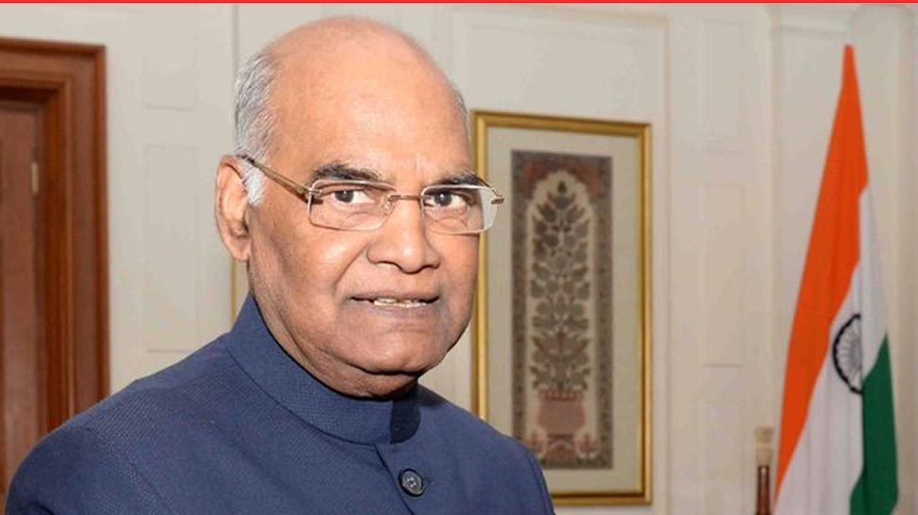
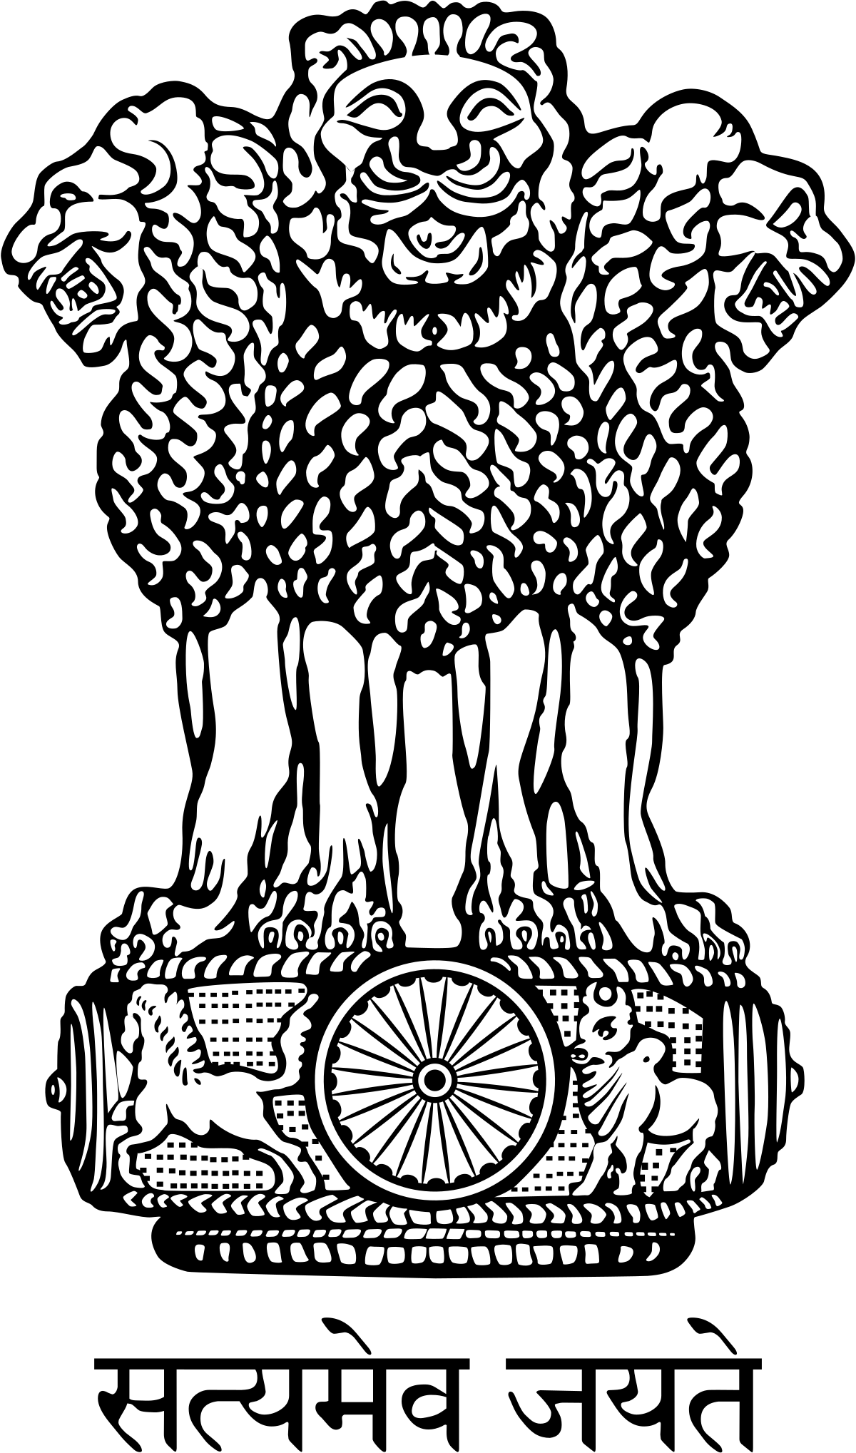
.

_________________ ________________ ________________ _____________
*****************************************************************
Class XII G.K. – 20th August 2019; Tuesday :
ALERT: BE WELL PREPARED & ALL THE BEST FOR THE MILESTONE OLYMPIAD [MSO] on 29-08- 2019; Thursday. Good Luck!
1. Expand UNICEF : ______________________________________________________________
2. Which among the following is the largest port of India?
a. Mumbai [ ] b. Paradip [ ] c. Kandla [ ] d. Tuticorin [ ]

3.Which among the following is the Highest Civilaian Award?
a. Param Veer Chakra [ ] b. Padmabhushan [ ]
c. Bharat Ratna [ ] d. Padmashree [ ]
4. When is International Yoga Day celebrated and since when? _____________________________________________________________________
*****************************************************************

